**Experiment-1**

**Student Name:** Hemant Narain Jha **UID:** 23BCS10022

**Branch:** CSE **Section/Group:** KRG-2B

**Semester:** 5th **Date of Performance:** 28-07-25

**Subject Name:** ADBMS **Subject Code:** 23CSP-333

# Aim:

* 1. Author-Book Relationship Using Joins and Basic SQL Operations.

Patient

* + - Design two tables — one for storing author details and the other for book details.
    - Ensure a foreign key relationship from the book to its respective author.
    - Insert at least three records in each table.
    - Perform an INNER JOIN to link each book with its author using the common author ID.
    - Select the book title, author name, and author’s country.

|  |  |  |
| --- | --- | --- |
| Author_id | Name | country |
| 1 | Haruki Murakami | Japan |
| 2 | Jane Austen | United Kingdom |
| 3 | Gabriel Garcia Marquez | Colombia |

|  |  |  |
| --- | --- | --- |
| book_id | Title | Author_id |
| 1 | Norweigian wood | 1 |
| 2 | Pride and prejudice | 2 |
| 3 | One hundred years of solitude | 3 |

# Objective:

* To understand how to use JOINS in SQL.
* To understand the basic SQL Queries.
* To learn how to create Foreign keys in SQL.

# DBMS Script :

**Query 1:**

-- Create Author table

CREATE TABLE AUTHOR (

author_id INTEGER PRIMARY KEY, -- Primary key for author_id

name VARCHAR(100) NOT NULL, -- Name of the author

country VARCHAR(100) NOT NULL -- Country of the author

);

-- Create Book table

CREATE TABLE BOOK (

book_id INTEGER PRIMARY KEY, -- Primary key for book_id

title VARCHAR(200) NOT NULL, -- Title of the book

author_id INTEGER, -- Foreign key linking to AUTHOR table

FOREIGN KEY (author_id) REFERENCES AUTHOR(author_id) -- Enforcing foreign key relationship

);

-- Insert data into Author table

INSERT INTO AUTHOR (author_id, name, country) VALUES

(1, 'Haruki Murakami', 'Japan'),

(2, 'Jane Austen', 'United Kingdom'),

(3, 'Gabriel Garcia Marquez', 'Colombia');

-- Insert data into Book table

INSERT INTO BOOK (book_id, title, author_id) VALUES

(1, 'Norwegian Wood', 1),

(2, 'Pride and Prejudice', 2),

(3, 'One Hundred Years of Solitude', 3);

-- Join the tables and select book title, author name, and author's country

SELECT

B.title AS Book_Title,

A.name AS Author_Name,

A.country AS Author_Country

FROM

BOOK AS B

INNER JOIN

AUTHOR AS A

ON

B.author_id = A.author_id;

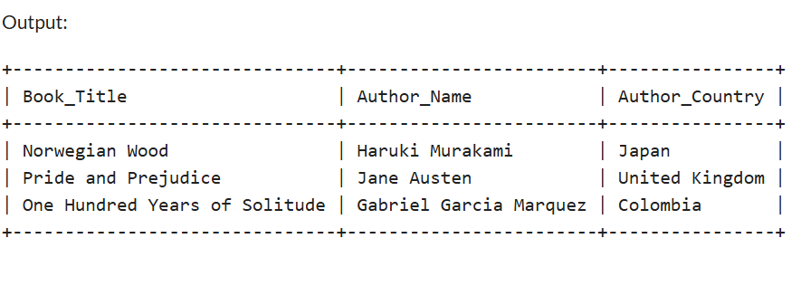

1. **Learning Outcomes:**

* You will be able to write basic SQL queries.
* You will learn to perform JOINS in SQL.
* You will understand how to implement foreign keys.